**Aim:** To study communication between two processes and the system calls .

**Theory:**

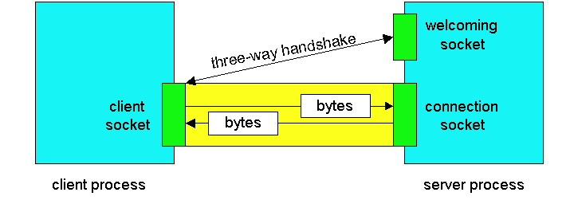

A socket is a communication endpoint to which an application can write data that are to be send out over the underlying network, and from which incoming data can be read. A socket forms an abstraction over the actual communication endpoint that is used by the local operating system for a specific transport protocol.

The following are the socket primitives for TCP/IP:

|  |  |
| --- | --- |
| Primitive | Meaning |
| Socket | Create a new communication end point. |
| Bind | Attach a local address to a socket. |
| Listen | Announce willingness to accept connections. |
| Accept | Block caller until a connection request arrives. |
| Connect | Actively attempt to establish a connection. |
| Send | Send some data over the connection. |
| Receive | Receive some data over the connection |
| Close | Release the connection. |

Servers generally execute the first four primitives, normally in the order given. When calling the socket primitive, the caller creates a new communication endpoint for a specific transportprotocol.

The bind primitive associates a local address with the newly created socket.

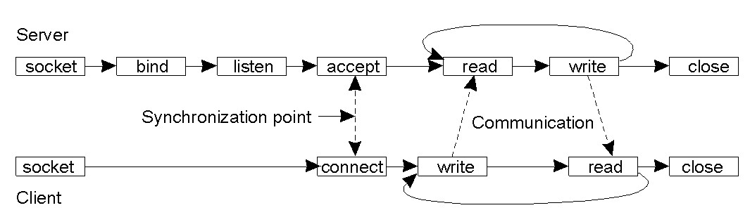

|  |
| --- |
| **Post lab:**   1. What is socket? 2. What is stream socket? 3. Differentiate between datagram and stream socket. |

Signature of Faculty